ATHLETICS
WALL HIGH SCHOOL
Marni Henry, Athletic Director
https://www.wallpublicschools.org/Page/2463
Follow us on Twitter @WallAthletics

Wall High School Sports Registration Process for Wall High School
Part A: Online Registration-Required for ALL students every sports season.
Athletic Registration must be completed for each student-athlete for each sports season (Fall/Winter/Spring). This registration can only be completed once per student-athlete per season and students may only register for ONE sport per season.
- Parents/Guardians: Sign into your Genesis Parent Portal account Genesis Sports Registration
- Select: “Forms”
- Select the current open season Sports Registration Form “Fall/Winter/or Spring Sports Registration”
Complete and submit this form in Genesis.
*If you have a student who attends one of the MCVSD Academies and lives in the Wall HS sending district:
1. Parents/Guardians: Sign into your Genesis Parent Portal account Genesis Sports Registration (User Name is the email given when you registered your child)
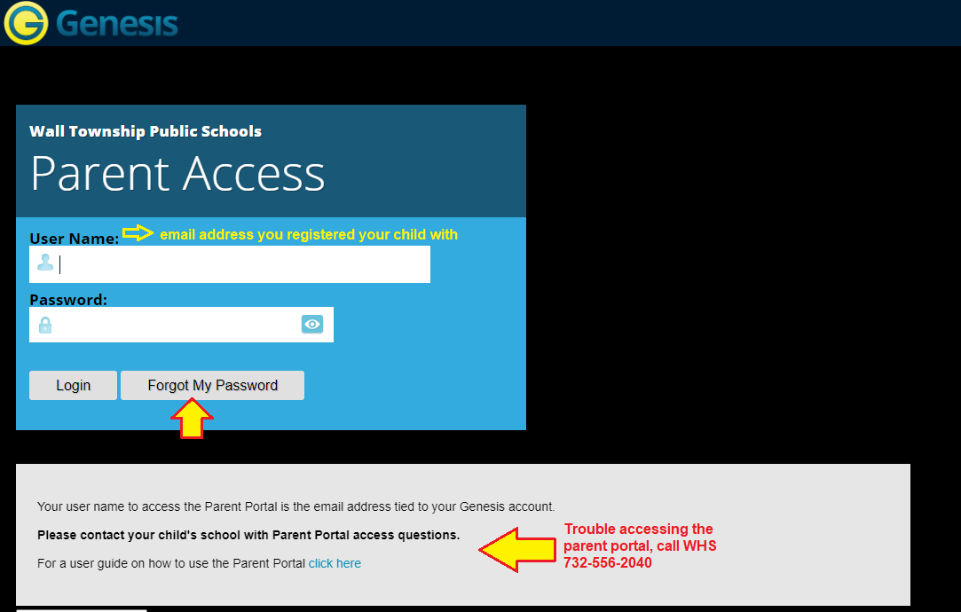
2. Select: “Forms”
3. Select the current open season Sports Registration Form “Fall/Winter/ or Spring Sports Registration (Out of District Students)”
Complete and submit this form in Genesis.

Part B: Medical Forms (physical)- Only required for students that do not have a valid sport physical.
Your child’s sports physical must be valid on the start date to begin practices/tryouts. Per NJ state law, all sports physicals must be reviewed and approved by the school physician prior to the first day of tryouts or practice. Please allow adequate time (at least two weeks) for this process, and keep in mind that additional clearance may be requested by the school physician on a case by case basis. Sports physicals are valid if they were conducted within 365 days of the first official practice/tryout.
If your child does not have a valid sport physical: Download, complete, and submit the Pre-Participation Physical Evaluation forms directly to the school nurse’s office. link here: Pre-Participation Physical Evaluation Form
*You must also complete the online sports registration forms (Part A) in the Genesis Parent Portal

All medical paperwork must be handed in, in its original form. Paperwork sent by email or fax will not be accepted by the nurse's office.
For more information please contact:
Amanda Marshcalk
amarschalk@wallpublicschools.org
Wall High School Nurse
Phone: 732.556.2070

